Problem 1

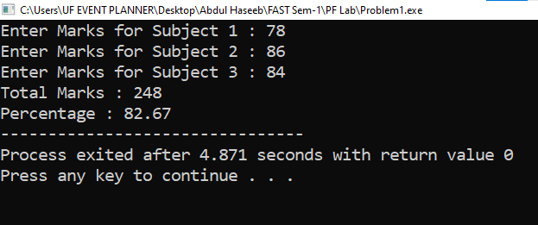

Problem 2

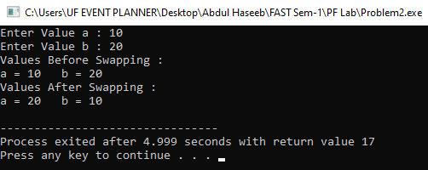

Problem 3

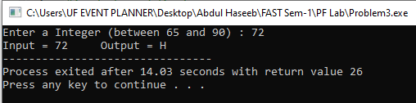

Problem 4

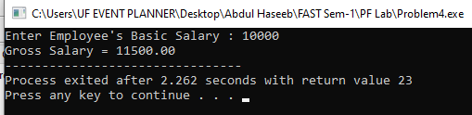

Problem 5

